notes to adjust the assignment:
1/ Do the company digital marketing audit by Comparing al marai with its competitors in terms of SOCIAL MEDIA ( youtube, twitter, Instagram, facebook..) how many followers they have, the number of posts...
THUS, mention the weakness and strengths of the company in THE DIGITAL MARKETING SOCIAL MEDIA ( link it to the recommendations ).
here is this point instruction in the slide follow it, please

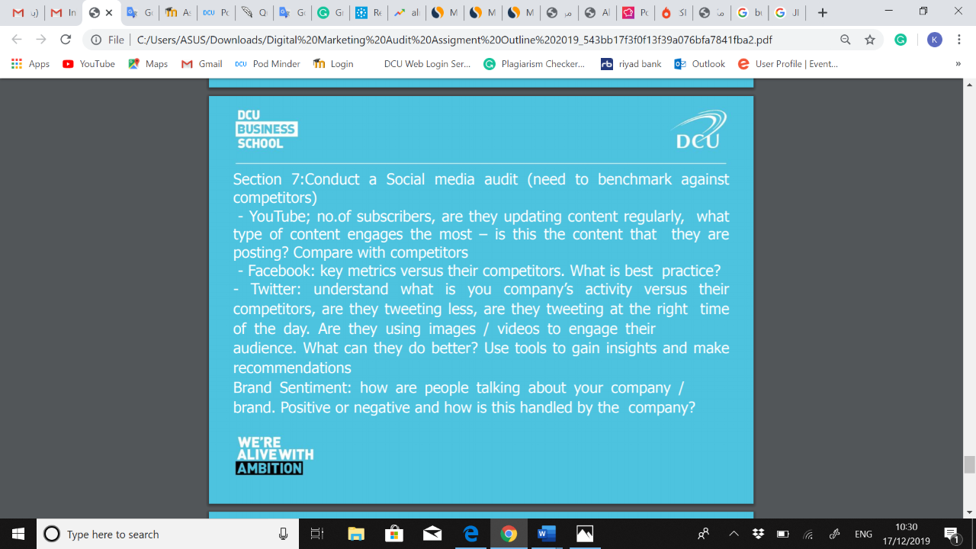

2/ Create a typical customer journey, including both TRADITIONAL and DIGITAL MEDIA for your product or service.
follow this model.

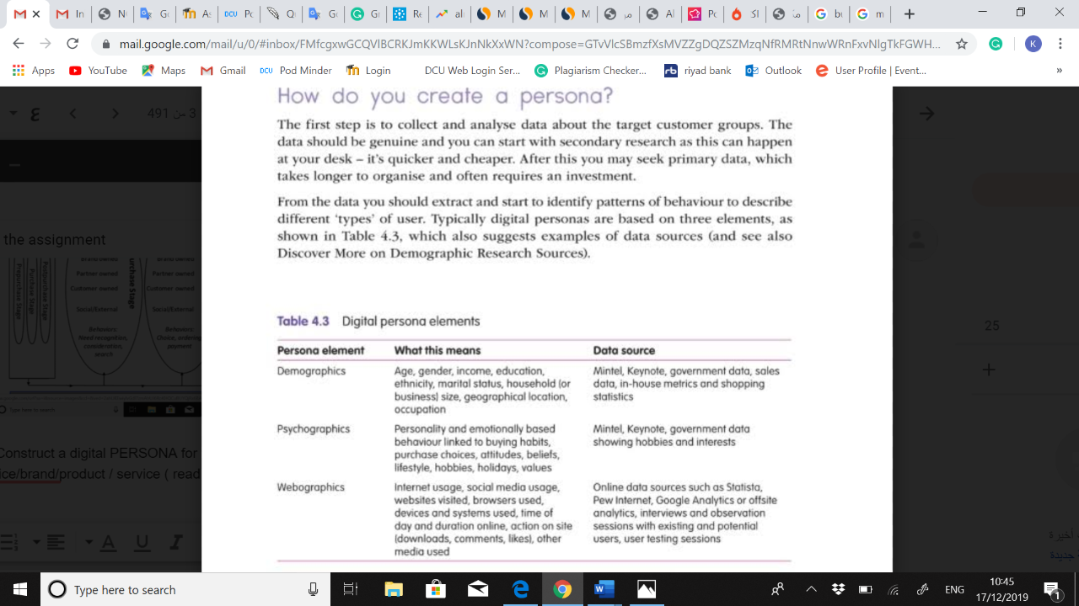

3/ Construct a digital PERSONA for the organization of your choice/brand/product / service ( read before you do what is persona)
do it accordingly to the diagram below.

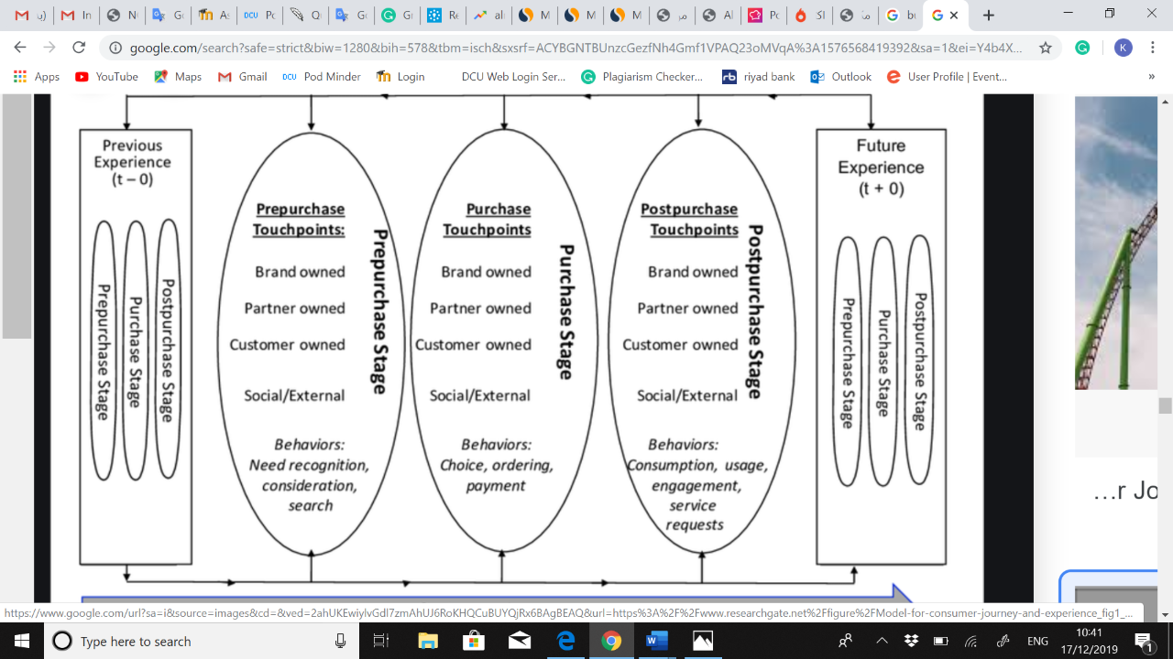

Add only this three-point and adjust the summary and recommendations based on it.
I NEED THE WORK ON 11:00 PM (17/12/2019) SO I CA REVISE BEFORE I SUBMIT IT

